Chavara Public School, Walwadi , Dhule
Grade- III C.B.S.E
Term- 2017-18
Subject- Science
Date:- 03/04/2018 M-60
QI) A) Fill in the blanks. M-5
- Accidents can occur on ___________ days.
- ___________ is experienced due to lack of rain.
- The symbol for litre is ____________.
- ___________ time is the hottest part of the body.
- The standard unit of length is ___________.
B) Tick the correct answer. M-5
1) Constellations are the patterns formed by ______________.
a) planets b) stars c) moons
2) Force can do ___________.
a) Nothing b) One thing c) Many things
3) A thermometer is used to measure __________.
a) pressure b) capacity c) temperature
4) Kidneys remove _____________.
a) carbon dioxide b) sweat c) urine
5) Beyond the layer of the earth is ____________.
a) atmosphere b) space c) force of gravity
QII) Match the following:- M-4
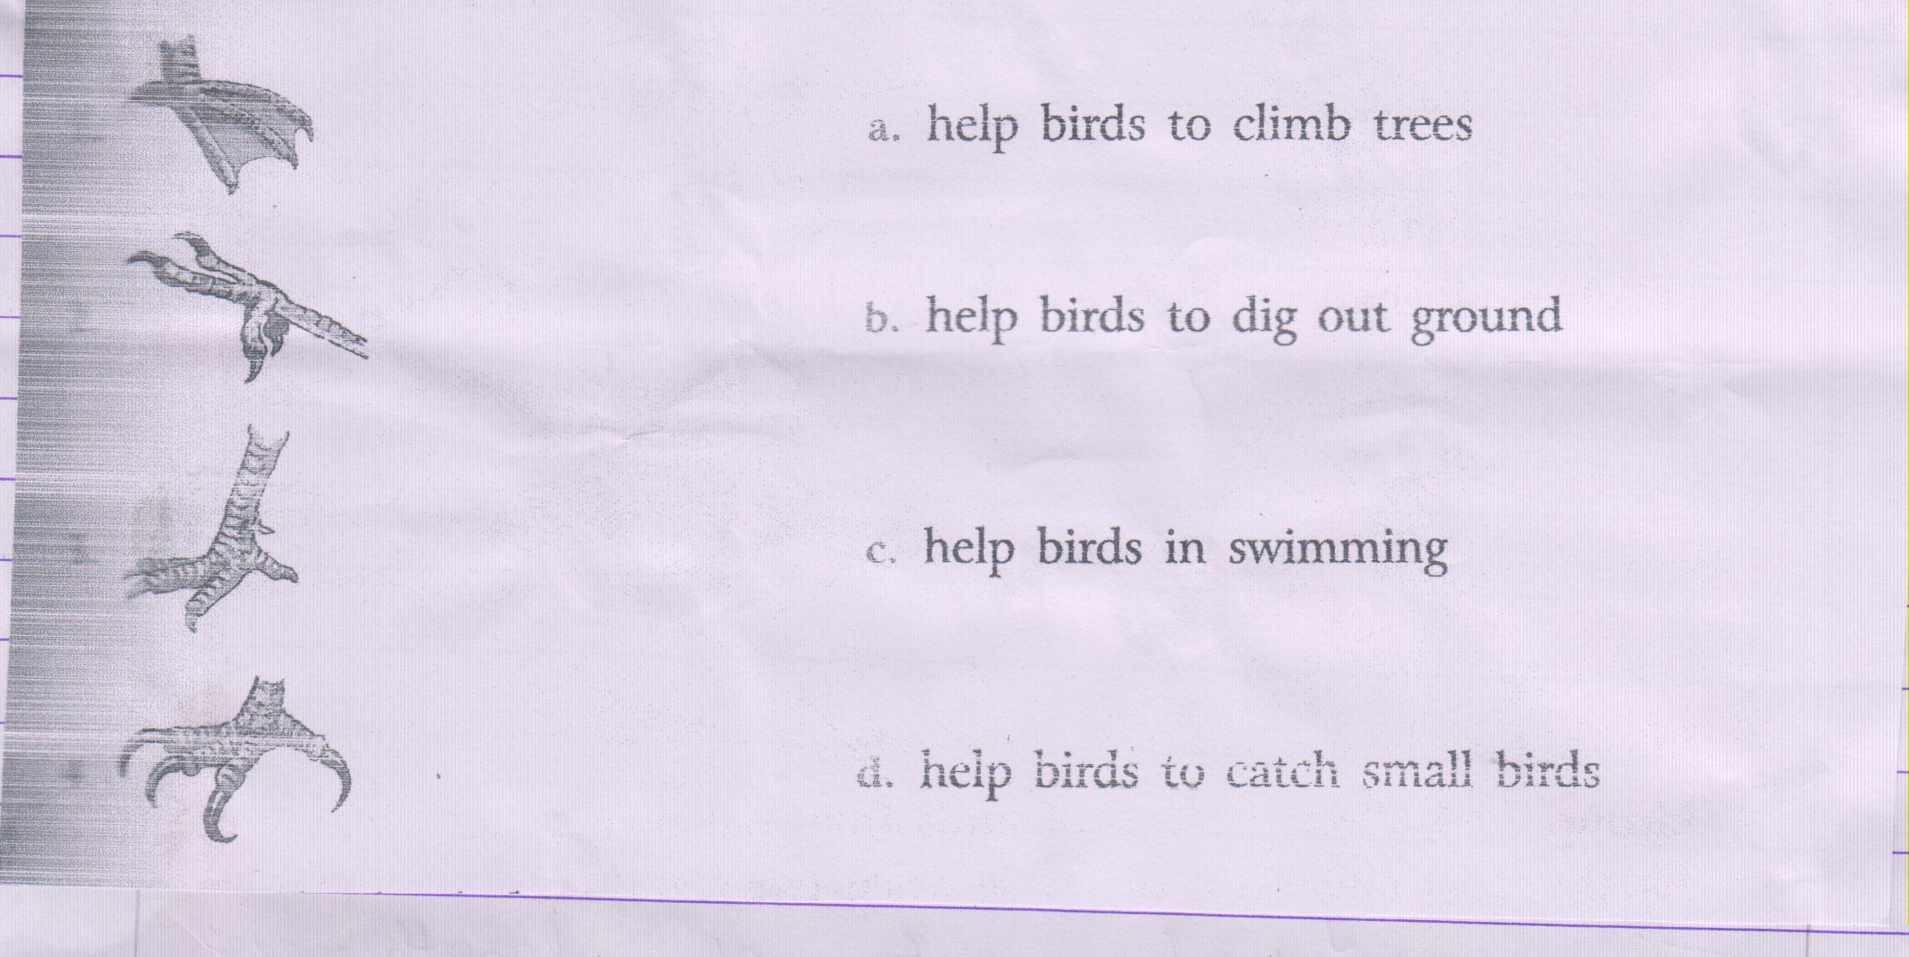

B) Circle the odd one out:- M-2
1) Ears Nose Heart Skin
2) Blood Nerves Heart Circulation
3) Kidneys Urine Brain Sweat
4) Small intestine Kidney Stomach Saliva
QIII) A) Name the bird that:- M-4
- Is front toes are joined by a skin.
- Makes its nest in the hollow of a tree.
- Collects pebbles and stones to make a nest.
- Collects a few sticks to make a cup-shaped nest.
B) Write the time taken for one. M-3
1) Rotation of the earth on its axis.
2) Revolution of the earth around the sun.
3) Rotation of the moon around the earth.
C) Name the following:- M-3
1) Light travels as thin beams of these.
2) This is formed when an object blocks the path of light.
3) This is cause by an unpleasant sound.
QIV) A) Who are we? Solve the riddles. M-3
- I have two discs in my name.
- The first three letters of my name is a sense organ.
- In twinkle in a popular nursery rhyme.
B) Answer in one word/ or two. M-5
1) Which are the 3 forms of water.
2) When did Kalpana Chawla die?
3) Name one constellation.
4) Name 2 luminous objects.
5) Name two scales used for measuring temperature.
QV) Answer the following. ( Any6) M-12
- What are the uses of a curved beak of a parakeet?
- What is the function of the reproductive system.
- What is capacity?
- What can we do to reduce noise?
- Who are astromers?
- Why is there no life on the moon?
- How do floods affect our life?
QVI) Think and answer:- ( Any2) M-5
- Why is noon the hottest part of the day?
- Out of Mercury, Earth and Neptune which planet is the hottest and which is the coldest ? Why?
- What should happen is water birds had toes not joined by a web?
QVII) Name a part of body which rhymes with the given words:- M-3
- South ___________
- Check ___________
- Nest _____________
- Dumb __________
- Thin __________
- See ___________
QVIII) Draw well labeled diagram of :- ( Any3) M-6
- Water cycle
- Solar system
- Tunar Eclipse
- Solar Eclipse

***************************

